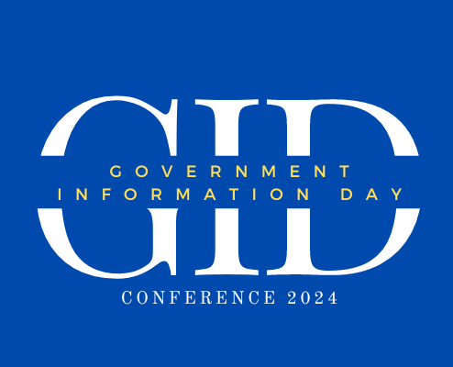

certifies that

_____________________

successfully completed 1 Library Education Unit for

attending the following presentation on May 17, 2024.

Keynote Address: Digital FDLP

Awarded on May 17, 2024

Scott Matheson

Superintendent of Documents, U.S. Government Publishing Office



# iNDIANA sTATE lIBRARY