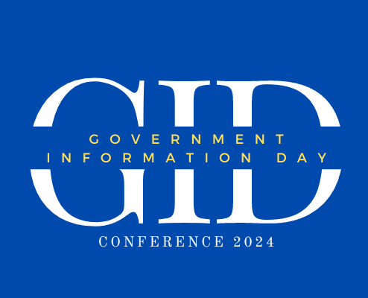

certifies that

_____________________

successfully completed 1 Library Education Unit for

attending the following presentation on May 17, 2024.

GPO’s Collaborations

Awarded on May 17, 2024

Suzanne Ebanues

Supervisory Management Analyst

U.S. Government Publishing Office



# iNDIANA sTATE lIBRARY