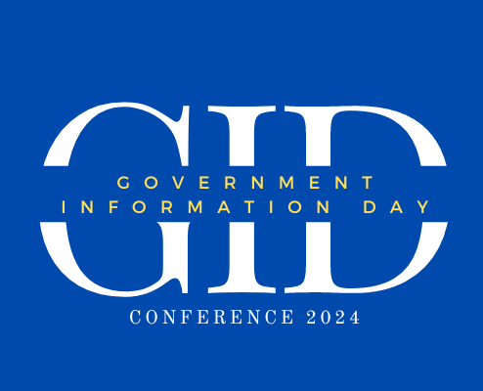

certifies that

_____________________

successfully completed 1 Library Education Unit for

attending the following presentation on May 17, 2024.

Escape Rooms, the Library of Congress, & YOU!

Awarded on May 17, 2024

Suzanne Walker

Director – Indiana Center for the Book

Indiana State Library

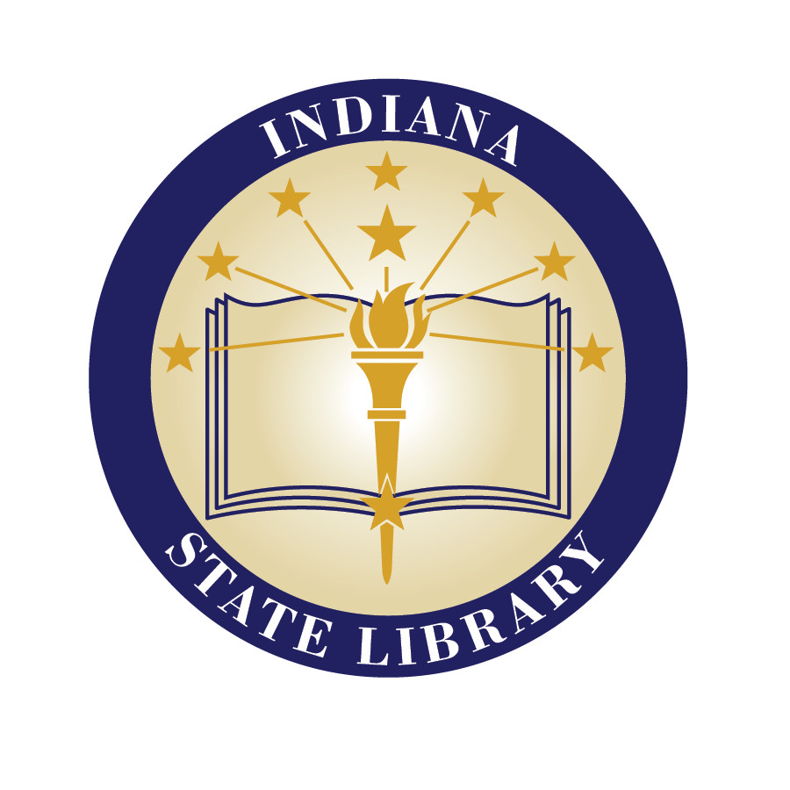

# iNDIANA sTATE lIBRARY